Agreements for Engagement

 | For be present, we draw from Carol Rodgers’s idea of presence. Be here, in the moment. Put aside thoughts about what you need to do after the meeting, what you need to do to prepare to teach. Be in your body, aware of all of your senses so that you are able to know how you are feeling, how you sound, what your body language is. Be present to those around you so that you can see the effect that you are having on them with your words and actions.
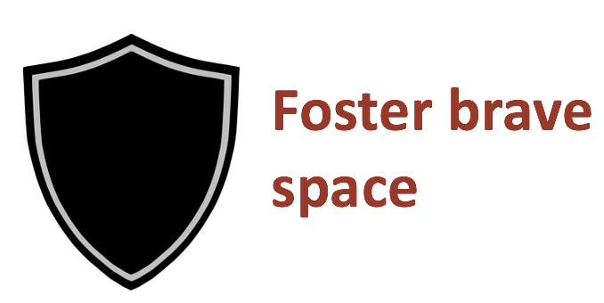 | Brave space is an extension of the idea of being present. A safe space is of course something we want, so that we have an environment where we, as learners, “are willing and able to participate and honestly struggle with challenging issues” (Holley & Steiner, 2005, p. 49 as cited in Arao & Clemens) but those of us who have privilege often hide behind a safe space whereas those who are from historically marginalized groups do not have a safe space. Instead, we want a brave space where learning involves being willing to be uncomfortable, to be held and hold each other accountable for what we say, when we say or do something that does harm or causes trauma to someone else or say or do something that deserves to be challenged so that we can grow. The brave space comes from Boostrom (1998) although others have also offered explanations.
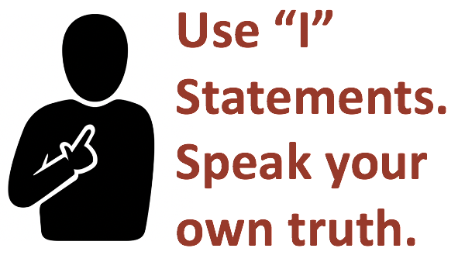 | I statements allow us as members of the community to speak our truths, including sharing our emotions, without placing blame on others. It allows us to speak from our own experiences, recognizing our positionality in relation to others. Using I statements is not just about using our personal experiences and anecdotal evidence in place of other sources, data and evidence. It simply allows the speaker to be assertive without being accusatory, which can make listeners defensive.
 | We see the need to engage in dialogue as an ongoing, continuous process. The ongoing nature of dialogue is what helps us pause, reflect and grow as individuals. Dialogue can be distinguished from discussions and debates. Dialogue is collaborative with an aim to listen to the other side in order to understand, find meaning and find agreement. Dialogue creates an open-minded attitude so it enlarges and possibly changes a participant’s point of view. Adapted from Shell Berman, which was based on discussions of the Dialogue Group of the Boston Chapter of Educators for Social Responsibility (ESR). Other members included Lucile Burt, Dick Mayo-Smith, Lally Stowell, and Gene Thompson
This is an agreement for equity. As an agreement, it asks group members to examine their participation patterns so that everyone has a chance to participate, not just those who always do.
It identifies and examines power dynamics within the group and works to interrupt these by pointing out discrepancies in who is talking, whose voices are being heard and whose are not.
While everyone has a “responsibility to step up and share what they know,” being aware of how much space they are taking and stepping back to allow others to share is important for an equitable and productive meeting. (aorta.collective.org)
This agreement refers to our humanity as we engage in difficult work.
While having a somewhat religious overtone, this agreement focuses on acknowledging that when work is difficult, mistakes are likely to be made during group work, and so a supportive environment is necessary as everyone in the group advances their understandings of the topics being discussed.
It’s important that “giving grace” doesn’t mean ignoring mistakes or ostracizing those who may make them, but finding what motivated a mistake and working as a group together to identify ways to move forward.
When mistakes are made, guilt or shame will not help to reflect on what prompted the mistake, and taking grace in the form of others’ support allows important work to continue cooperatively.
This agreement asks us all to resist assigning blame on ourselves and others, and to seek understanding and provide support for continued development in the work at hand, giving and taking support as needed.

Consider in FLCs:
- There are many truths
- Stories stay, Lessons leave
- Be slow to understand (don’t assume someone’s meaning)
- Foster accountability to our Rossier mission and to disrupting anti-Blackness and white supremacy
- Use research evidence and empirical data, not opinion

Process suggestions within FLCs
- Add a contingency plan – what if there are instances of serious harm – what are things that can be done to repair/mitigate in moment?
- Maybe we could use an approach like a progressive stack for conversations in the whole group when there are many people who want to share or ask a question. This means it is not a first volunteer, first speak, but rather including those who speak less often or who represent minoritized identities, experiences or views.

